`
Batch: B1 Roll No.: 1711072

Experiment / assignment / tutorial No.01

Grade: AA / AB / BB / BC / CC / CD /DD

Signature of the Staff In-charge with date

TITLE : GCD and LCM

AIM: Write a recursive function ‘GCD’ to find the GCD of the given two numbers. Use this in main to find the GCD and LCM two given numbers. (Scanner class)
______________________________________________________________________
Expected OUTCOME of Experiment:

CO 2. Solve problems using Java basic constructs (like if else statement, control structures, and data types, array, string, vectors, packages, collection class).
_____________________________________________________________________
Books/ Journals/ Websites referred:

- Ralph Bravaco , Shai Simoson , “Java Programing From the Group Up” Tata McGraw-Hill.

- Grady Booch, Object Oriented Analysis and Design .
_____________________________________________________________________
Pre Lab/ Prior Concepts:

The Scanner class is a class in java.util, which allows the user to read values of various types. There are far more methods in class Scanner than you will need in this course. We only cover a small useful subset, ones that allow us to read in numeric values from either the keyboard or file without having to convert them from strings and determine if there are more values to be read.

Scanner in = new Scanner(System.in); // System.in is an InputStream
Numeric and String Methods

Method | Returns
int nextInt() | Returns the next token as an int. If the next token is not an integer,InputMismatchException is thrown.
long nextLong() | Returns the next token as a long. If the next token is not an integer,InputMismatchException is thrown.
float nextFloat() | Returns the next token as a float. If the next token is not a float or is out of range, InputMismatchException is thrown.
double nextDouble() | Returns the next token as a long. If the next token is not a float or is out of range, InputMismatchException is thrown.
String next() | Finds and returns the next complete token from this scanner and returns it as a string; a token is usually ended by whitespace such as a blank or line break. If not token exists,NoSuchElementException is thrown.
String nextLine() | Returns the rest of the current line, excluding any line separator at the end.
void close() | Closes the scanner.

The Scanner looks for tokens in the input. A token is a series of characters that ends with what Java calls whitespace. A whitespace character can be a blank, a tab character, a carriage return. Thus, if we read a line that has a series of numbers separated by blanks, the scanner will take each number as a separate token. .
The numeric values may all be on one line with blanks between each value or may be on separate lines. Whitespace characters (blanks or carriage returns) act as separators. The next method returns the next input value as a string, regardless of what is keyed. For example, given the following code segment and data
int number = in.nextInt();
float real = in.nextFloat();
long number2 = in.nextLong();
double real2 = in.nextDouble();
String string = in.next();

Class Diagram:
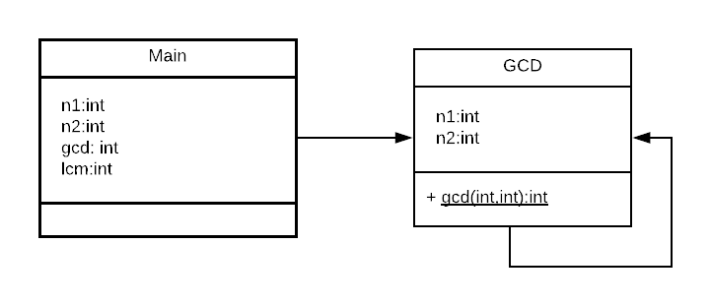

Algorithm:
Main function
Step 1: START
Step 2: PRINT “Enter two numbers: ”
Step 3: INPUT n1 and n2
Step 4: gcd = CALL calc.gcd(arguments : n1 , n2)
Step 5: lcm=(n1*n2)/gcd
Step 6: PRINT gcd
Step 7: PRINT lcm
Step 8: STOP
GCD (parameters n1 , n2) function
Step 1: START
Step 2: IF n1==0 Return n2
Step 3: ELSE Return RECURSIVELY gcd( n2%n1 , n1 )

Implementation details:
import java.util.Scanner;
class Main
{
public static void main(String args[])
{
Scanner read = new Scanner(System.in);
GCD calc = new GCD();
int n1,n2;
System.out.println("Enter two numbers: ");
n1=read.nextInt();
n2=read.nextInt();

int gcd = calc.gcd(n1,n2);
int lcm = n1*n2/gcd;

System.out.println("The LCM is "+ lcm +" and GCD is "+ gcd);
}
}
class GCD
{
public static int gcd(int n1,int n2)
{
if(n1==0)
return n2;
else
return gcd(n2%n1,n1);
}
}
For cross verification, code is available at:
https://repl.it/@ARGHYADEEPDAS/DarkvioletZigzagTask

Output Screen:
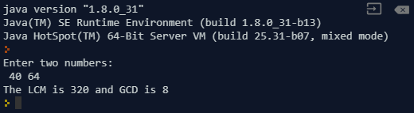

Conclusion: In this experiment, we learn the difference between static, non-static functions and members of functions. We implement the code for various cases, and got the expected output.
Post Lab Descriptive Questions (Add questions from examination point view)

Q.1What is the meaning of Return data type void?
a). An empty memory space is returned so that the developers can utilize it.
b). void returns no data type.
c). void is not supported in Java
d). None of the above
Ans. b) Void returns no data type.
Q.2 Write the output of following program
Class Sample{
int a;
static int b=5;
public static void main(String args[]) {
a=10;
b=10;
System.out.println(“a=”+a+” b=”+b);
}
- a=5 b=10
- a=10 b=10
- compile time error
- a=10 b=5
Ans. 3) The code will throw a compile time error as braces aren’t closed for class.

Q.3 Write a recursive static method for calculation of factorial of n number.
import java.util.*;
class factorial
{
static int fact(int n)
{
int result;
if(n==1)
return 1;
result = fact(n-1) * n;
return result;
}
}
class Main
{
static int f,n;
public static void main(String [] args)
{

int i;
System.out.println("Enter number of numbers: ");
Scanner s = new Scanner(System.in);
factorial u = new factorial();
i = s.nextInt();
do
{
System.out.println("Enter number: ");
f = s.nextInt();
n = u.fact(f);
System.out.print("The Factorial of " +f );
System.out.println(" is "+n);
i--;
}while(i>0);
}
}

Date: 21/07/2018 Signature of faculty in-charge

Batch: B1 Roll No.: 1711072

Experiment / assignment / tutorial No. 02

Grade: AA / AB / BB / BC / CC / CD /DD

Signature of the Staff In-charge with date

TITLE :Multi-dimensional Arrays

AIM: Write a program which stores information about n players in a two dimensional array. The array should contain number of rows equal to number of players. Each row will have number of columns equal to number of matches played by that player which may vary from player to player. The program should display player number (index +1), runs scored in all matches and its batting average as output. (It is expected to assign columns to each row dynamically after getting value from user.
_____________________________________________________________________
Expected OUTCOME of Experiment:

CO2: Solve problems using Java basic constructs (like if else statement, control structures, and data types, array, string, vectors, packages, collection class).

Books/ Journals/ Websites referred:

1. Ralph Bravaco , Shai Simoson , “Java Programing From the Group Up” Tata McGraw-Hill.

2.Grady Booch, Object Oriented Analysis and Design .
_____________________________________________________________________
Pre Lab/ Prior Concepts:

Arrays:
Multi-Dimensional Array:
10 12 43 11 22
20 45 56 1 33
30 67 32 14 44
40 12 87 14 55
50 86 66 13 66
60 53 44 12 11
A multi-dimensional array is one that can hold all the values above. You set them up like this:
int[ ][ ] numbers = new int[6][5];
The first set of square brackets is for the rows and the second set of square brackets is for the columns. In the above line of code, we're telling Java to set up an array with 6 rows and 5 columns.
aryNumbers[0][0] = 10;
aryNumbers[0][1] = 12;
aryNumbers[0][2] = 43;
aryNumbers[0][3] = 11;
aryNumbers[0][4] = 22;
So the first row is row 0. The columns then go from 0 to 4, which is 5 items.
Class Diagram:

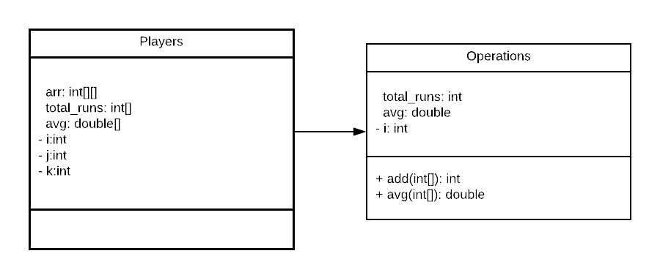

Implementation details:
import java.util.*;
import java.text.DecimalFormat;
class Operations{
public int add(int arr[]){
int total_runs=0;
for(int i=0;i<arr.length;i++){
total_runs+=arr[i];
}
return total_runs;
}
public double avg(int arr[]){
double avg=0.0;
int total_runs=0;
for(int i=0;i<arr.length;i++){
total_runs+=arr[i];
}
return (float)total_runs/(float)arr.length;
}
}
public class Players {
public static void main(String[] args) {
System.out.print("Enter number of players: ");
Scanner sc=new Scanner(System.in);
DecimalFormat df=new DecimalFormat("#.00");
int n=sc.nextInt();
Operations op=new Operations();
int[][] arr= new int[n][];
int[] total_runs=new int[n];
double[] avg=new double[n];
for(int i=0;i<n;i++){
System.out.print("Enter number of matches of player "+(i+1)+": ");
int j=sc.nextInt();
arr[i]=new int[j];
System.out.println("Enter runs scored in each match: ");
for(int k=0;k<arr[i].length;k++){
arr[i][k]=sc.nextInt();
}
}
System.out.println("Player\t\tTotal Runs\t\tAverage");
for(int i=0;i<n;i++){
total_runs[i]=op.add(arr[i]);
avg[i]=op.avg(arr[i]);
System.out.println("Player "+(i+1)+"\t"+total_runs[i]+"\t\t\t"+df.format(avg[i]));
}
}
}

For cross verification, the code can be found at: https://repl.it/@ARGHYADEEPDAS/ArghyadeepDasOOPMExperiments

Output Screen:
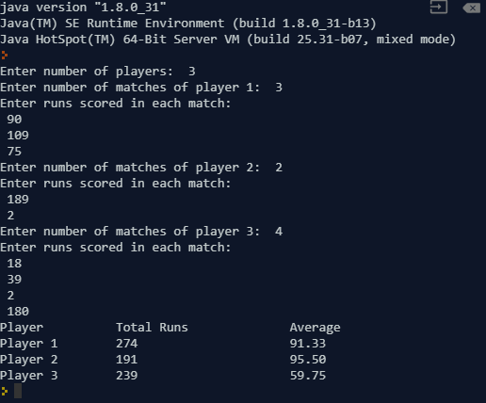
Conclusion: The concept of jagged array was implemented, arrays were passed as parameters and arrays were returned. The program ran successfully and the aim of the experiment was met.

Post Lab Descriptive Questions (Add questions from examination point view)

Q.1 Which of the following statements are valid array declaration?
(A) int number();
(B) float average[];
(C) double[] marks;
(D) counter int[];

(i) (D)

(ii) (A) & (C)

(iii) (A)

(iv) (B) & (C)

Option (iv) contains the choices which are valid declarations.

Q.2 Consider the following code:
int number[] = new int[5];
After execution of this statement, which of the following are true?
(A) number[0] is undefined
(B) number[5] is undefined
(C) number[4] is null
(D) number[2] is 0
(E) number.length() is 5

(i) (C) & (E)

(ii) (A) & (E)

(iii) (E)

(iv) (B), (D) & (E)

Option (iv) is correct. An array which is declared is initialized as 0 for int type. 5th element is number[4] but not number[5]. Length of array is 5.

Q.3 What will be the content of array variable table after executing the following code?
for(int i = 0; i < 3; i + +)
for(int j = 0; j < 3; j + +)
if(j = i) table[i][j] = 1;
else table[i][j] = 0;

A). 0 0 0
0 0 0
0 0 0

B). 0 0 1
0 1 0
1 0 0

C). 1 0 0
1 1 0
1 1 1

D) 1 0 0
0 1 0
0 0 1

Option D gives the correct array pattern since the given logic allocates non-zero value to diagonal elements only (diagonal elements are those which have row number=column number in a square matrix).

Date: 28/07/2018 Signature of faculty in-charge

Batch: Roll No.:

Experiment / assignment / tutorial No.03

Grade: AA / AB / BB / BC / CC / CD /DD

Signature of the Staff In-charge with date

TITLE :Case Study (for Class Diagram)

AIM : Draw class Diagram for the Airline Reservation System. Clearly show attributes, multiplicities and aggregations/compositions/Association between classes in the class diagram. And show the implementation of aggregation, association and composition between the classes. ______________________________________________________________________
Expected OUTCOME of Experiment:

CO3: Implement scenarios using object oriented concepts(Drawing class diagram, relationship between classes , sequence diagram)
_____________________________________________________________________
Books/ Journals/ Websites referred:

1.Ralph Bravaco , Shai Simoson , “Java Programing From the Group Up” Tata McGraw-Hill.
2.Grady Booch, Object Oriented Analysis and Design .

_____________________________________________________________________
Pre Lab/ Prior Concepts:

Define Class, Methods and Object.
What is Aggregation and Association.

List Of Classes:

Identify Attributes in classes:

Identify List of Methods in classes:

Class Diagram:

Implementation details:
Conclusion:

Date: __________ Signature of faculty in-charge

Post Lab Descriptive Questions (Add questions from examination point view)

1. Consider the following class:
public class IdentifyMyParts {
public static int x = 7;
public int y = 3;
}
a). What are the class variables?

b). What are the instance variables?

c).What is the output from the following code:
IdentifyMyParts a = new IdentifyMyParts();
IdentifyMyParts b = new IdentifyMyParts();
a.y = 5;
b.y = 6;
a.x = 1;
b.x = 2;
System.out.println("a.y = " + a.y);
System.out.println("b.y = " + b.y);
System.out.println("a.x = " + a.x);
System.out.println("b.x = " + b.x);
System.out.println("IdentifyMyParts.x = " + IdentifyMyParts.x);

Batch: B1 Roll No.: 1711072

Experiment / assignment / tutorial No.04

Grade: AA / AB / BB / BC / CC / CD /DD

Signature of the Staff In-charge with date

TITLE : String and String Buffer

AIM : Write a program to check if two Strings are anagrams of each other (Make use of String Functions) . Use the built- in functions available with String class.
______________________________________________________________________
Expected OUTCOME of Experiment:

CO2:Solve problems using Java basic constructs (like if else statement, control structures, and data types, array, string, vectors, packages, collection class).

_____________________________________________________________________
Books/ Journals/ Websites referred:

1.Ralph Bravaco , Shai Simoson , “Java Programing From the Group Up” Tata McGraw-Hill.
2.Grady Booch, Object Oriented Analysis and Design .
_____________________________________________________________________
Pre Lab/ Prior Concepts:
Q. 1. Explain how to declare a String Literal, how to create a String variables in java. Use of charAt() function in java.
Ans. To declare a string literal, we do:
String test=”Hello Somaiya!”;
To create String variable (Object), we use the new keyword.
String str=new String(“Hello Somaiya”);
We use charAt() function to return the char value at specified index.
Q.2.Explain different functions of String Class.
- String concat(String);
s1.concat(s2) concatenates String s2 at the end of String s1. If not assigned to s1, String s1 isn’t modified.
- int length();
s1.length() returns the length of the sequence of characters represented by String s1.
- char charAt(int);
s1.charAt(i) returns the character present at index i in String s1.
- int hashCode();
s1.hashCode() returns the hash value of the String which is used to store the string in hash table.
- boolean startsWith(String);
s1.startsWith(s2) returns True or False depending on whether the String s1 begins with String s2.
- String replaceAll(String, String);
s1.replaceAll(s2,s3) is used to replace substring s2 with substring s3 wherever found in s1.
- String trim();
s1.trim() returns a new string with leading and trailing whitespaces omitted.

Q.3. Explain different functions of StringBuffer Class.
- append(String);
s1.append(s2); is used to append string s2 to string s1.
- delete(int, int);
s1.delete(4,9); deletes the characters from index 4 to index 9(exclusive) from String s1.

- substring(int, int);
s1.substring(2,10); returns the substring of s1 from index 2 to 10 (exclusive).
- reverse();
s1.reverse(); returns the reversed string s1. (Actually, StringBuffer s1).
- replace(int, int, String);
s1.replace(5,9, “fine”); will replace the substring of s1 from index 5 to 8 with string “fine”.
Class Diagram:

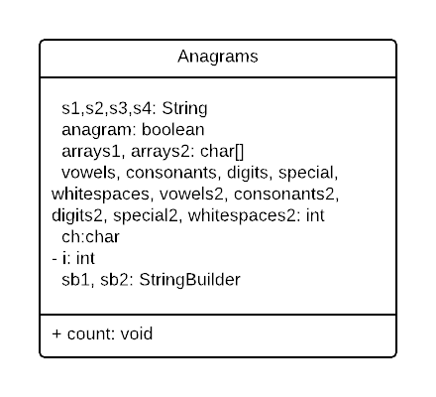

Algorithm:
STEP 1: START.
STEP 2: Take two strings from user; s1 and s2.
STEP 3: Remove all the extra whitespaces from both the strings.
STEP 4: If length of s1 is not equal to s2, return FALSE.
STEP 5: Convert strings s1 and s2 to lowercase character arrays.
STEP 6: Sort the two arrays.
STEP 7: If the two arrays are equal, then return TRUE.
STEP 8: Pass the strings through for loop by iterating over each letter.
STEP 9: If character is a digit, increment digits.
STEP 10: If character is a consonant, increment consonants.
STEP 11: If character is a vowel, decrement consonants and increase vowels.
STEP 12: If character is a whitespace, increment whitespaces.
STEP 13: If character is none of the above, increment special.
STEP 14: Use built-in method of StringBuilder class to reverse the strings and display.
STEP 15: END.

Implementation details:
import java.util.*;
import java.lang.*;
class Anagrams {
public static void main(String[] args) {
Scanner sc=new Scanner(System.in);
System.out.print("Enter first string: ");
String s1=sc.nextLine();
String s3=s1;
System.out.print("Enter second string: ");
String s2=sc.nextLine();
String s4=s2;
System.out.println("First string is: "+s1+"\nSecond string is: "+s2);
s1=s1.replaceAll("\\s", "");
s2=s2.replaceAll("\\s", "");
boolean anagram=true;
if(s1.length()!=s2.length())
anagram=false;
char[] arrays1=s1.toLowerCase().toCharArray();
char[] arrays2=s2.toLowerCase().toCharArray();
Arrays.sort(arrays1);
Arrays.sort(arrays2);
anagram=Arrays.equals(arrays1,arrays2);
if(anagram)
System.out.println("They are anagrams.");
else
System.out.println("They are not anagrams.");
count(s3,s4);
StringBuilder sb1=new StringBuilder(s3);
StringBuilder sb2=new StringBuilder(s4);
System.out.println("Reversed String s1: "+sb1.reverse().toString());
System.out.println("Reversed String s2: "+sb2.reverse().toString());
}
public static void count(String s3, String s4){
int vowels=0, consonants=0, digits=0, whitespaces=0, special=0;
System.out.println(s3);
s3=s3.toLowerCase();
for(int i=0;i<s3.length();i++){
char ch= s3.charAt(i);
if(Character.isDigit(ch))
digits++;
else if(Character.isWhitespace(ch))
whitespaces++;
else if(Character.isLetter(ch)){
consonants++;
if(ch=='a' || ch=='e' || ch=='i' || ch=='o' || ch=='u'){
consonants--;
vowels++;
}
}
else
special++;
}
System.out.println("Vowels: "+vowels+"\nConsonants: "+consonants+"\nDigits: "+digits+"\nWhitespaces: "+whitespaces+"\nSpecial Characters: "+special);
System.out.println(s4);
s4=s4.toLowerCase();
int vowels2=0, consonants2=0, digits2=0, whitespaces2=0, special2=0;
for(int i=0;i<s4.length();i++){
char ch= s4.charAt(i);
if(Character.isDigit(ch))
digits2++;
else if(Character.isWhitespace(ch))
whitespaces2++;
else if(Character.isLetter(ch)){
consonants2++;
if(ch=='a' || ch=='e' || ch=='i' || ch=='o' || ch=='u'){
consonants2--;
vowels2++;
}
}
else
special2++;
}
System.out.println("Vowels: "+vowels2+"\nConsonants: "+consonants2+"\nDigits: "+digits2+"\nWhitespaces: "+whitespaces2+"\nSpecial Characters: "+special2);
}
}

Output Screen:
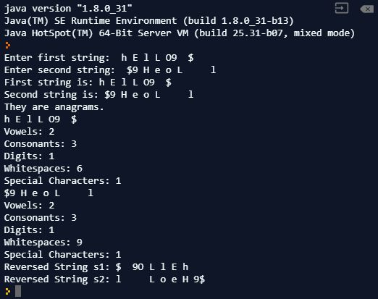
For cross verification, the code can be found at: https://repl.it/@ARGHYADEEPDAS/OOPMExp4
Conclusion:
The program was executed successfully. Various methods of String, StringBuffer and StringBuilder class were implemented to successfully create the program.

Post Lab Descriptive Questions (Add questions from examination point view)

1 Explain string functions.
String class in Java has some built in methods which developers can implement to make their codes concise and also reduce the redundancy and make code more presentable. Some of them are:
- String concat(String);
s1.concat(s2) concatenates String s2 at the end of String s1. If not assigned to s1, String s1 isn’t modified.
- int length();
s1.length() returns the length of the sequence of characters represented by String s1.
- char charAt(int);
s1.charAt(i) returns the character present at index i in String s1.
- boolean startsWith(String);
s1.startsWith(s2) returns True or False depending on whether the String s1 begins with String s2.
- String replaceAll(String, String);
s1.replaceAll(s2,s3) is used to replace substring s2 with substring s3 wherever found in s1.
- String trim();
s1.trim() returns a new string with leading and trailing whitespaces omitted.

Q.2 Select all correct declarations, or declaration and initializations of an
array?
A) String str[];
B) String str[5] = new String[5];
C) String str[]=new String [] {"string1", "string 2", "string3", "string4",
"string5"};
D) String str[]= {"string1","string2", "string3", "string4", "string5"};
Ans. Options A,C,D are valid syntaxes for declaration/initialization of an array.
Q.3Suppose that s1 and s2 are two strings. Which of the statements or expressions are valid?
(A) String s3 = s1 + s2;
(B) String s3 = s1 - s2;
(C) s1 <= s2
(D) s1.compareTo(s2);
(E) int m = s1.length();
(i).A, B, C
(ii)A, D, E
(iii)C, D, E
(iv)D, E
(v)A, C, E
Ans. ii) A-> Concatenation of strings. D-> Valid String method. E->String length.

4.What is the output of the following program?
public class AA {
public static void main(String args[]) {
String s1 = "abc";
String s2 = "def";
String s3 = s1.concat(s2.toUpperCase( ) );
System.out.println(s1+s2+s3);
}
}

Ans. Output= abcdefabcDEF

5 What is the difference between String and StringBuffer?

Ans.
String | StringBuffer
String class is immutable. | StringBuffer class is mutable.
String is slow and consumes more memory when you concatenate too many strings because every time it creates new instances. | StringBuffer is fast and consumes less space when concatenating strings.
String class overrides the equals() method of Object class. So, you can compare contents of two strings with equals(). | StringBuffer class doesn’t override the equals() method of Object class.

6 Which package does define String and StringBuffer classes?
Ans. Package which contains String class is java.lang.String. Package which contains StringBuffer class is java.lang.StringBuffer. Both can be simply called or imported using “import java.lang.*;” .

- Write a function to search for the existence of a string (target) in another string (str). The function takes two strings as the input and returns the index where the second string is found. If the target string cannot be found, then return -1.
Ans. int findString(String str, String target)
{
return str.indexOf(target);
}

8.Which method can be used to find out the total allocated capacity of a StringBuffer?
Ans. If a StringBuffer object is buff, the method to find allocated capacity will be buff.capacity().
Java.lang.StringBuffer.capacity().

9.Which method can be used to set the length of the buffer within a StringBuffer object?
Ans. The java.lang.StringBuffer.setLength() method sets the length of the buffer. If the StringBuffer object is buff, the length will be set using buff.setLength(9).

Date: 03/08/2018 Signature of faculty in-charge

Batch: Roll No.:

Experiment / assignment / tutorial No.05

Grade: AA / AB / BB / BC / CC / CD /DD

Signature of the Staff In-charge with date

TITLE :User Defined Exception

AIM : Write a program which accepts marks of a student (between 0 to 100) and checks whether it is within the range or not. If it is within the range then it displays “marks entered successfully”, if not then it throws the exception of user defined class “MarksOutOfRangeException”. The class should contain appropriate toString method to describe object the class with the out of range marks entered by the user.
______________________________________________________________________
Expected OUTCOME of Experiment:

CO4:Demonstrate programs on interface, exceptions, multithreading and applets. _____________________________________________________________________
Books/ Journals/ Websites referred:

1.Ralph Bravaco , Shai Simoson , “Java Programing From the Group Up” Tata McGraw-Hill.

2.Grady Booch, Object Oriented Analysis and Design .

_____________________________________________________________________
Pre Lab/ Prior Concepts:

PRIORITY QUEUE :

Explain how to create a user define exception and explicitly throwing exception in program with simple example.

Class Diagram:

Algorithm:

Implementation details: (printout of code)
Conclusion

Date: ___________ Signature of faculty in-charge

Post Lab Descriptive Questions (Add questions from examination point view)

1. compare throw and throws.

Batch: Roll No.:

Experiment / assignment / tutorial No.06

Grade: AA / AB / BB / BC / CC / CD /DD

Signature of the Staff In-charge with date

TITLE :Vector and array of objects and Enumeration/Iterator

AIM : Create a class ShoppingList which stores Name of the items ,item id ,cost, and total no.of a items. Use class Vector to maintain an array of items in the descending order of the cost.
- Accepts a shopping list from the command line and stores them in a vector.
- To delete an specific item (given by user) in the vector
- Add item at the end of the vector
- Add item at specific location
Print the contents of vector.
Provide the following functions
1) create() : this function will accept the n items records in any order and will arrange them in the sorted order. This data will be accepted from the command line and stores them in a vector.
2) insert : to insert the given item at appropriate index in the vector depending upon the grand total.
3) deleteByName( ) : to accept the name of the item and delete the record having given name
4) deleteById( ): to accept the id of the item and delete the record having given roll no.
______________________________________________________________________
Expected OUTCOME of Experiment:

CO2:Solve problems using Java basic constructs (like if else statement, control structures, and data types, array, string, vectors, packages, collection class).
_____________________________________________________________________
Books/ Journals/ Websites referred:
- Ralph Bravaco , Shai Simoson , “Java Programing From the Group Up” Tata McGraw-Hill.

2.Grady Booch, Object Oriented Analysis and Design .
__________________________________________________________
Pre Lab/ Prior Concepts:

Class Diagram:

Algorithm:

Implementation details: (printout of code)
Conclusion

Date:_______ Signature of faculty in-charge

Post Lab Descriptive Questions (Add questions from examination point view)

1 Expain methods of Vector class in detail with the help of Example.

Batch: Roll No.:

Experiment / assignment / tutorial No.07

Grade: AA / AB / BB / BC / CC / CD /DD

Signature of the Staff In-charge with date

TITLE : Multithreading Programming

AIM : A class ThreadDemo stores a thread name and an array of Strings
Constructor accepts the name of the thread and size of the array .It then creates the array with the given size and reads the elements of the array.The thread displays “thread-name starts” and then it display all the string one by one .Write a program to create two threads of the class, one of them display the days of week and the other displays the months of the years.The main thread should also display “main thread active”when it gets the timeslice.
______________________________________________________________________
Expected OUTCOME of Experiment:

CO4:Demonstrate programs on interface, exceptions, multithreading and applets. _____________________________________________________________________
Books/ Journals/ Websites referred:

- Ralph Bravaco , Shai Simoson , “Java Programing From the Group Up” Tata McGraw-Hill.

2.Grady Booch, Object Oriented Analysis and Design .
___________________________________________________________
Pre Lab/ Prior Concepts:
Java provides built-in support for multithreaded programming. A multithreaded program contains two or more parts that can run concurrently. Each part of such a program is called a thread, and each thread defines a separate path of execution.A multithreading is a specialized form of multitasking. Multithreading requires less overhead than multitasking processing.
Multithreading enables you to write very efficient programs that make maximum use of the CPU, because idle time can be kept to a minimum.

Creating a Thread:
Java defines two ways in which this can be accomplished:
- You can implement the Runnable interface.
- You can extend the Thread class itself.

Create Thread by Implementing Runnable:
The easiest way to create a thread is to create a class that implements the Runnable interface.
To implement Runnable, a class needs to only implement a single method called run( ), which is declared like this:
public void run( )
You will define the code that constitutes the new thread inside run() method. It is important to understand that run() can call other methods, use other classes, and declare variables, just like the main thread can.
After you create a class that implements Runnable, you will instantiate an object of type Thread from within that class. Thread defines several constructors. The one that we will use is shown here:
Thread(Runnable threadOb, String threadName);
Here, threadOb is an instance of a class that implements the Runnable interface and the name of the new thread is specified by threadName.
After the new thread is created, it will not start running until you call its start( ) method, which is declared within Thread. The start( ) method is shown here:
void start( );
Here is an example that creates a new thread and starts it running:
class NewThread implements Runnable {
Thread t;
NewThread() {
t = new Thread(this, "Demo Thread");
System.out.println("Child thread: " + t);
t.start(); // Start the thread
}
public void run() {
try {
for(int i = 5; i > 0; i--) {
System.out.println("Child Thread: " + i);
// Let the thread sleep for a while.
Thread.sleep(50);
}
} catch (InterruptedException e) {
System.out.println("Child interrupted.");
}
System.out.println("Exiting child thread.");
}
}

public class ThreadDemo {
public static void main(String args[]) {
new NewThread();
try {
for(int i = 5; i > 0; i--) {
System.out.println("Main Thread: " + i);
Thread.sleep(100);
}
} catch (InterruptedException e) {
System.out.println("Main thread interrupted.");
}
System.out.println("Main thread exiting.");
}
}

The second way to create a thread is to create a new class that extends Thread, and then to create an instance of that class.
The extending class must override the run( ) method, which is the entry point for the new thread. It must also call start( ) to begin execution of the new thread.
class NewThread extends Thread {
NewThread() {
super("Demo Thread");
System.out.println("Child thread: " + this);
start(); // Start the thread
}
public void run() {
try {
for(int i = 5; i > 0; i--) {
System.out.println("Child Thread: " + i);
// Let the thread sleep for a while.
Thread.sleep(50);
}
} catch (InterruptedException e) {
System.out.println("Child interrupted.");
}
System.out.println("Exiting child thread.");
}
}

public class ExtendThread {
public static void main(String args[]) {
new NewThread(); // create a new thread
try {
for(int i = 5; i > 0; i--) {
System.out.println("Main Thread: " + i);
Thread.sleep(100);
}
} catch (InterruptedException e) {
System.out.println("Main thread interrupted.");
}
System.out.println("Main thread exiting.");
}
}

Some of the Thread methods

methods | description
void setName(String name) | Changes the name of the Thread object. There is also a getName() method for retrieving the name
void setPriority(int priority) | Sets the priority of this Thread object. The possible values are between 1 and 10. 5
boolean isAlive() | Returns true if the thread is alive, which is any time after the thread has been started but before it runs to completion.
void yield() | Causes the currently running thread to yield to any other threads of the same priority that are waiting to be scheduled.
void sleep(long millisec) | Causes the currently running thread to block for at least the specified number of milliseconds.
Thread currentThread() | Returns a reference to the currently running thread, which is the thread that invokes this method.
Class Diagram:

Algorithm:

Implementation details: (printout of code)
Conclusion

Date:________ Signature of faculty in-charge

Post Lab Descriptive Questions (Add questions from examination point view)

1.What do you mean by multithreading?

.2 Explain the use of sleep and run function with an example?

Batch: Roll No.:

Experiment / assignment / tutorial No.08

Grade: AA / AB / BB / BC / CC / CD /DD

Signature of the Staff In-charge with date

TITLE : PACKAGES

AIM: Write a program to create a package ‘myPack’ which contains a class Trigonometry. The class contains following static methods.
i) sine() –accepts degree (0,30,60,90)
ii) cos() - accepts degree (0,30,60,90)
iii)tan()- accepts degree (0,30,60,90)
iv)cot()-- accepts degree (0,30,60,90)
v)cosec()-- accepts degree (0,30,60,90)
vi)sec()-- accepts degree (0,30,60,90)
(Do not make use of inbuilt functions. Use the functions of user defined class Trigonometry by importing mypack.)
______________________________________________________________________
Expected OUTCOME of Experiment:

CO4: Demonstrate programs on interface, exceptions, multithreading and applets. _____________________________________________________________________
Books/ Journals/ Websites referred:

1. Balagurusamy, E. Programming With Java:A Primer 3E , Tata McGraw-Hill Education, 2006

2. Herbert schildt, The Complete Reference JAVA2, 2nd ed., TMH, 2002
___________________________________________________________
Pre Lab/ Prior Concepts:
A package is a collection of related classes. It helps to rganize your classes into a folder structure and makes it easy to locate and use them. More importantly,It helps improve re-usability.
. Packages are used for:
1. Preventing naming conflicts. For example there can be two classes with name Employee in two packages, college.staff.cse.Employee and college.staff.ee.Employee
2. Making searching/locating and usage of classes, interfaces, enumerations and annotations easier
3. Providing controlled access: protected and default have package level access control. A protected member is accessible by classes in the same package and its subclasses. A default member (without any access specifier) is accessible by classes in the same package only.
4. Packages can be considered as data encapsulation (or data-hiding).
Adding a class to a Package: We can add more classes to an created package by using package name at the top of the program and saving it in the package directory. We need a new java file to define a public class, otherwise we can add the new class to an existing .java file and recompile it.
Subpackages: Packages that are inside another package are the subpackages. These are not imported by default, they have to imported explicitly. Also, members of a subpackage have no access privileges, i.e., they are considered as different package for protected and default access specifiers.
Example :
import java.util.*;
util is a subpackage created inside java package.

To create a package(Example)
Step 1) Copy the following code into an editor
package p1;
class c1{
public void m1(){
System.out.println("Method m1 of Class c1");
}
public static void main(String args[]){
c1 obj = new c1();
obj.m1();
}}
Step 2) Save the file as Demo.java. Compile the file as, javac – d . Demo.java
Step 3) Run the code as java p1.c1
To create a sub-package
Step1) Copy the following code into an editor

package p1.p2;
class c2{
public void m2(){
System.out.println("Method m2 of Class c2");
}
public static void main(String args[]){
c2 obj = new c2();
obj.m2();
}}

Step 2) Save the file as Demo2.java. Compile the file as javac – d . Demo2.java
Step 3) Run the code as java p1.p2.c2

Algoritham:

Implementation details: (printout of code)

Conclusion

Date:_____________ Signature of faculty in-charge

Post Lab Descriptive Questions (Add questions from examination point view)

1. Discuss the various levels of access protection available for packages and their implications.
2. Which package is used for pattern matching with regular expressions?

Batch: Roll No.:

Experiment / assignment / tutorial No.10

Grade: AA / AB / BB / BC / CC / CD /DD

Signature of the Staff In-charge with date

TITLE :Creating an applet.

AIM : Write a java applet program for a problem definition of your own choice.
______________________________________________________________________
Expected OUTCOME of Experiment:

CO4:Demonstrate programs on interface, exceptions, multithreading and applets.
_____________________________________________________________________
Books/ Journals/ Websites referred:

1.Ralph Bravaco , Shai Simoson , “Java Programing From the Group Up” Tata McGraw-Hill.
2.Grady Booch, Object Oriented Analysis and Design .
_____________________________________________________________________
Pre Lab/ Prior Concepts:

Theory: An applet is a small Java program that is embedded and ran in some other Java interpreter program such as Java technology-enabled browser, Sun’s applet viewer program called appletviewer
Creating SimpleApplet in java:
import java.applet.*;
import java.awt.*;

public class HelloWorldApplet extends Applet
{
public void paint (Graphics g)
{
g.drawString ("Hello World", 25, 50);
}
}
First two import statements bring the classes into the scope of our applet class. Without those import statements, the Java compiler would not recognize the classes Applet and Graphics, which the applet class refers to.

Running Applet in java:
An applet may be invoked by embedding directives in an HTML file and viewing the file through an applet viewer or Java-enabled browser.
The <applet> tag is the basis for embedding an applet in an HTML file. Below is an example that invokes the "Hello, World" applet:
<html>
<title>The HelloWorld Applet</title>
<body>
<hr>
<applet code="HelloWorldApplet.class" width="320" height="120">
<param Name=”string” Value=”Hello”>
<param name="audio" value="test.wav">
If your browser was Java-enabled, a "Hello, World"
message would appear here.

</applet>
<hr>
</body>
</html>
The code attribute of the <applet> tag is required. It specifies the Applet class to run. Width and height are also required to specify the initial size of the panel in which an applet runs. The applet directive must be closed with a </applet> tag.
If an applet takes parameters, values may be passed for the parameters by adding <param> tags between <applet> and </applet>. The browser ignores text and other tags between the applet tags.
Non-Java-enabled browsers do not process <applet> and </applet>. Therefore, anything that appears between the tags, not related to the applet, is visible in non-Java-enabled browsers.
Attributes of Applet tag:
Attribute | Explanation | Example
Code | Name of class file | Code=“applet0.class”
Width | Width of applet | Width=300
height | Height of applet | Height=60
Codebase | Applet’s Directory | Codebase=“/applets”
Alt | Alternate text if applet not available | Alt=“menu applet”
name | Name of the applet | Name=“appletExam”
Align (top,left,right,bottom) | Justify the applet with text | Align=“right

Class Diagram:

Algorithm:

Implementation details: (printout of code)
Conclusion

Date:_____________ Signature of faculty in-charge

Post Lab Descriptive Questions (Add questions from examination point view)

1 Explain Applet Life cycle.

2.Write the difference between Applets and Standalone Java applications.

Batch: Roll No.:

Experiment / assignment / tutorial No.11

Grade: AA / AB / BB / BC / CC / CD /DD

Signature of the Staff In-charge with date

TITLE : Mini project in Java with database connectivity(GUI designing using AWT/JDBC).

AIM : Write a java applet program for a problem definition of your own choice.
______________________________________________________________________
Expected OUTCOME of Experiment:

CO4:Demonstrate programs on interface, exceptions, multithreading and applets.
_____________________________________________________________________
Books/ Journals/ Websites referred:

1.Ralph Bravaco , Shai Simoson , “Java Programing From the Group Up” Tata McGraw-Hill.
2.Grady Booch, Object Oriented Analysis and Design .
_____________________________________________________________________
Pre Lab/ Prior Concepts:

Group Members:

Theory:
Self-Learning Component:
Description of the components used while developing the mini project.

Class Diagram for Mini Project:

Algorithm:

Implementation details: (printout of code)
Conclusion

Date:_____________ Signature of faculty in-charge

